**DAILY ONLINE ACTIVITIES SUMMARY**

|  |  |  |  |  |  |  |  |  |
| --- | --- | --- | --- | --- | --- | --- | --- | --- |
| **Date:** | **11/06/2020** | | | | | **Name:** | **NAIPUNYA VINOD NAIK** | |
| **Sem & Sec** | **IV SEM & A SECTION** | | | | | **USN:** | **4AL18CS050** | |
| **Online Test Summary** | | | | | | | | |
| **Subject** | | **N/A** | | | | | | |
| **Max. Marks** | | **N/A** | | **Score** | | | **N/A** | |
| **Certification Course Summary** | | | | | | | | |
| **Course** | **INTRODUCTION TO PROGRAMMING** | | | | | | | |
| **Certificate Provider** | | | **GREAT LEARNING**  **ACADEMY** | | **Duration** | | | **5.5 HRS** |
| **Coding Challenges** | | | | | | | | |
| **Problem Statement:1)** [Write a Java Program to Segregate Even and Odd numbers](https://github.com/orgs/alvas-education-foundation/teams/2nd-year/discussions/114). | | | | | | | | |
| **Status: EXECUTED** | | | | | | | | |
| **Uploaded the report in Github** | | | | | **YES** | | | |
| **If yes Repository name** | | | | | <https://github.com/naipunya-naik/lockdown-coding/blob/master/JAVA%20CODING/segregate_11-06-2020.java> | | | |
| **Uploaded the report in slack** | | | | | **YES** | | | |

Online Test Details: (Attach the snapshot and briefly write the report for the same).

NO INTERNALS CONDUCTED

Certification Course Details: (Attach the snapshot and briefly write the report for the same)

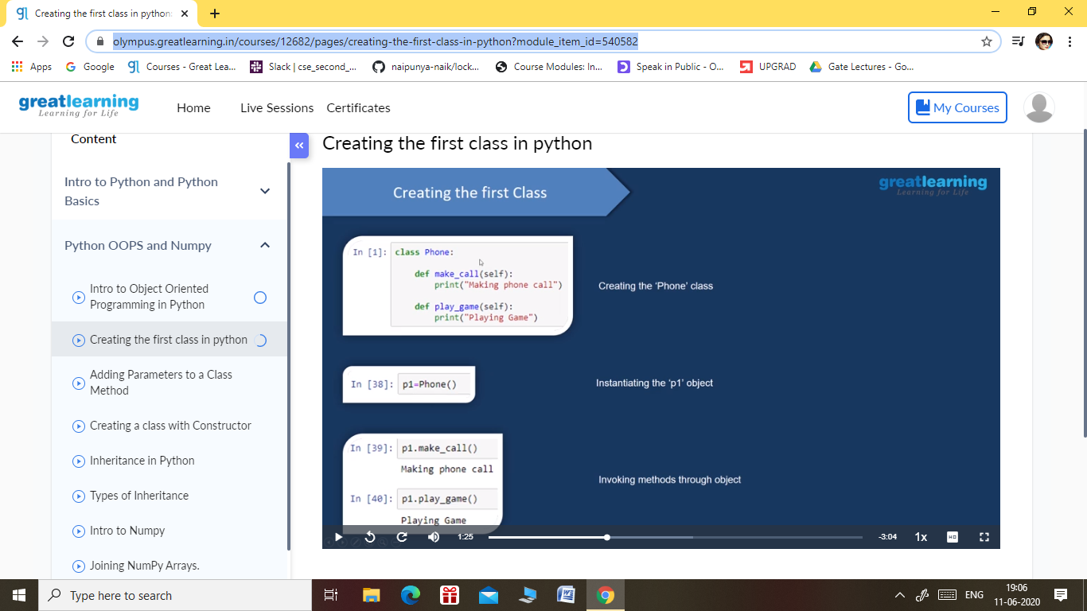

1. Intro to Object Oriented Programming in Python
2. Creating the first class in python
3. Adding Parameters to a Class Method
4. Creating a class with Constructor
5. Inheritance in Python
6. Types of Inheritance
7. Intro to Numpy
8. Joining NumPy Arrays.
9. Numpy Intersection & Difference
10. Numpy Array Mathematics
11. Saving and Loading Numpy Array

Coding Challenges Details: (Attach the snapshot and briefly write the report for the same).

[Write a Java Program to Segregate Even and Odd numbers](https://github.com/orgs/alvas-education-foundation/teams/2nd-year/discussions/114)

Top of Form

Bottom of Form

|  |
| --- |
| Given an array A[], write a function that segregates even and odd numbers. The functions should put all even numbers first, and then odd numbers. Example:  Input = {12, 34, 45, 9, 8, 90, 3} Output = {12, 34, 8, 90, 45, 9, 3}  Algorithm: segregateEvenOdd()   1. Initialize two index variables left and right: left = 0, right = size -1 2. Keep incrementing left index until we see an odd number. 3. Keep decrementing right index until we see an even number. 4. If lef < right then swap arr[left] and arr[right]   Screenshot (119).png |

GITHUB REPOSITORY LINK:-

<https://github.com/naipunya-naik/lockdown-coding/blob/master/JAVA%20CODING/segregate_11-06-2020.java>